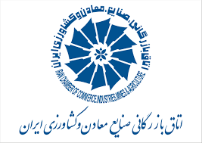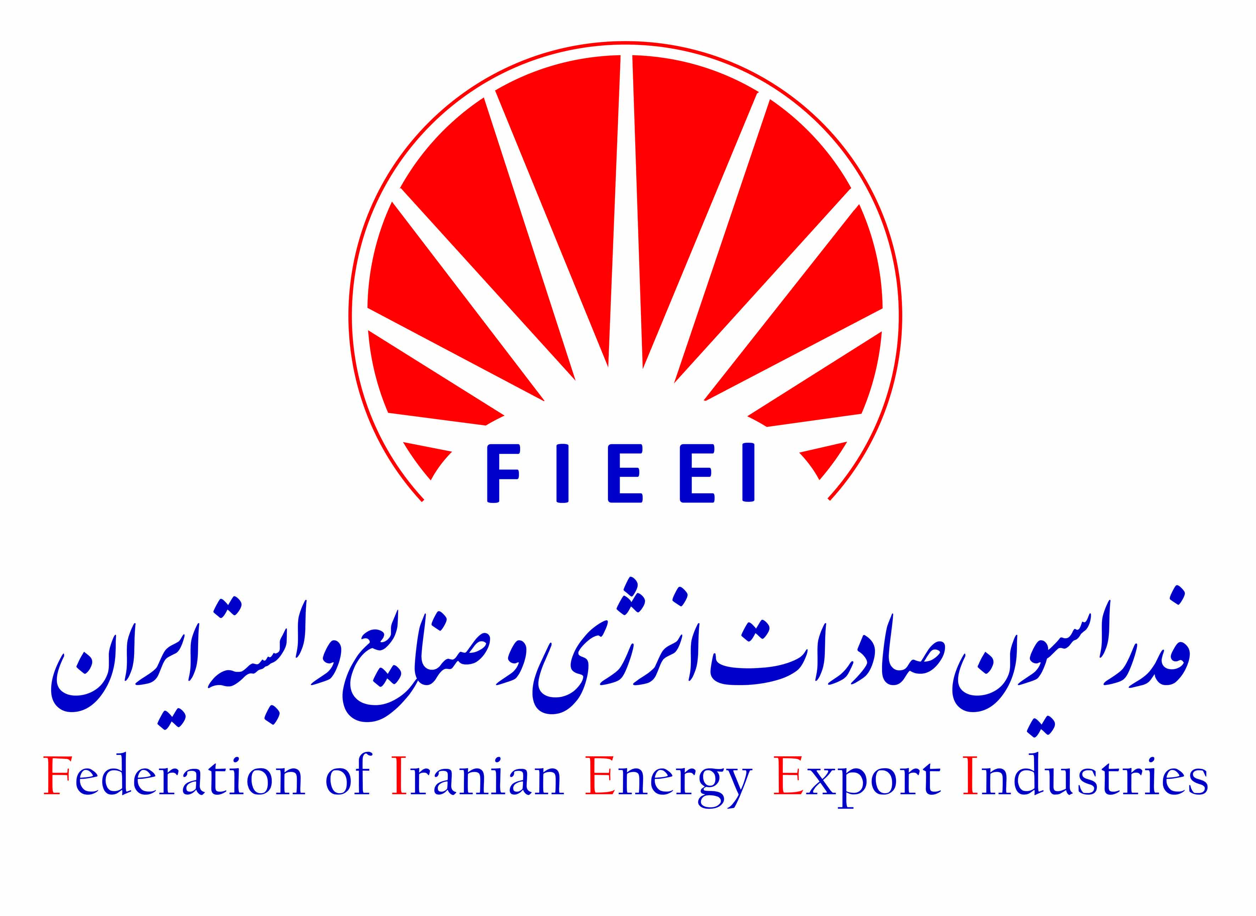

“2nd Meeting of the ECO Public and Private Sector
Energy/Petrochemical Consortium/Companies”

The Federation of Energy Industries of Iran in collaboration with ECO Secretariat, ECO CCI and ICCIMA(Iran Chamber of Commerce, Industries, Mining and Agriculture), is proud to announce the holding of the “2nd Meeting of the ECO Public and Private Sector Energy/Petrochemical Consortium/Companies”.

Background
In the declaration made by the 3rd ECO Ministerial Meeting on Energy/Petroleum on 6th March, 2013, I.R Iran, the issue of private and public cooperation in energy related projects was welcomed and emphasized. The Regional Planning Council –RPC, kept this issue in ECO event calendar at the following meetings during the 2014 and 2015. Eventually in 2016, the “1st Meeting of the ECO Public and Private Sector Energy/Petrochemical Consortium/Companies” took place in Iran. It was attended by the delegates from public and private sectors from the Islamic Republic of Afghanistan, Republic of Azerbaijan, the Islamic Republic of Iran, Republic of Kazakhstan, the Islamic Republic of Pakistan, Republic of Tajikistan, and Republic of Turkey, as well as delegations from the ECO-CCI, ECO-TDB, IDB and ECO Secretariat.
Following the effective and successful 1st meeting in August 2016, the Regional Planning Council -RPC at its 28th Meeting in Islamabad, 11-14 December 2017, scheduled the second meeting for 2018.

About ECO
Economic Cooperation Organization (ECO) is an inter-governmental regional organization encompassing countries from Caucuses and Central Asia, Middle East and South Asia with more than 460 million inhabitants and over 8 million square kilometers connecting Russia to Persian Gulf and China to Europe. The overall objective of the Organization is the sustainable economic development of its Member States and the Region as a whole.
Over the past three decades or so, the ECO Member States have been collaborating to accelerate the pace of regional development through their common endeavors. Besides shared cultural and historic affinities, they have been able to use the existing infrastructural and business links to further fortify their resolve to transfer their hopes and aspirations into a tangible reality.
In March 2017, Heads of States/Government of the Member States in their 13th Summit in Islamabad endorsed “ECO Vision 2025” where main directions of the ECO in the years to come are drawn.

Energy Policy of ECO
Enhancing the energy security and sustainability through wider energy access and trade within the ECO Region and beyond is among the top priorities within ECO. Energy demand is growing in pace with the socio-economic development of ECO Member States, requiring adequate, efficient and equitable provision of energy services. In this connection it is imperative to develop and consolidate common efforts to ensure regional energy sustainability and resilience, in line with ECO Decade for Enhanced Energy Cooperation (2013-2022), projected ECO Plan of Action for Energy/Petroleum Cooperation (2016-2020), Global Sustainable Development Goals, and in coherence with other energy related activities and projections envisaged in the ECO Vision 2025. Accordingly, energy trade, including regional electricity trade; uplifting the renewable energy share in the ECO Region energy profile; enhancing the energy interconnectivity and ensuring affordable access to all sources of energy are among the targets pursued by ECO.

About the Organizers
The Federation of Energy Industries of Iran in collaboration with ECO Secretariat, ECO CCI and ICCIMA and in affiliation with Ministry of Oil and Ministry of Power is responsible for the holding of the “2nd Meeting of the ECO Public and Private Sector Energy/Petrochemical Consortium/Companies”

The major concern for the organizers is to provide a win-win platform for all participants coming from 10 different ECO countries and to specifically serve the private sector companies to find partners and benefit from projects in the whole region.

Actions
The Organizers are putting together a comprehensive list of available energy related projects. There has been a call to public and private sectors of every ECO country to provide feasible projects with potential of cooperation and establishment of energy consortiums.
The efforts of building a database of Iranian projects have been paying off and soon the whole database will be decimated among member states.

Participants

- Iranian Oil and power ministers
- High level ECO secretariat
- High level Energy authorities from ECO member states
- High level authorities from Iranian and ECO region Chamber of Commerce
- ECO region ambassadors and high level policy makers
- Director of the ECO Trade and Development Bank (ETDB)
- Director of the Islamic Development Bank (IDB)
- Director of the Asian Development Bank (ADB)
- High level delegates from European energy companies
- CEOs from many private Iranian and ECO region energy companies
- Academic from European and ECO region countries
- Etc.

Conference Activities

Leisure
- Visit to the largest special energy zones in southern Iran, in cooperation with the Iranian Oil Ministry
- Visit to the largest power plant equipment maker in Iran
- Dinner invitation (Gala)

Academic
- Certification and presentation of articles reviewed and accepted by scientific committee
- Workshop presentations by high level academics and prominent energy companies (companies interested in holding workshops can contact the secretariat)

Why participate?

- Considering the great energy potentials in the ECO region, creating cooperating mechanisms such as consortiums brings prosperity to private and public companies in the region as well as people and governments receiving the services.

- Regulating and organizing required contracts for major projects in the region, help better understanding of flow of energy and provides better opportunities for international financing organizations to invest.

- The establishment of these energy consortiums speeds up and facilitates the erection of major projects in the ECO region and helps the recipients of infrastructural projects to make their selections in an orderly manner.

- Organizing cooperative mechanisms in the ECO region facilitates design and definition of major regional projects and helps strategic decision making.

DRAFT AGENDA

- Inauguration of the Meeting
- Election of the Chairperson
- Adoption of the Agenda
- Establishment of the Drafting Committee
- Brief review and follow-up of decisions and recommendations of the 1st Meeting of ECO Public and Private Sector Energy/Petrochemical Consortiums/Companies
- Statements/Presentations by the Member States within the Panel Discussions on:
- Ways and means of galvanizing financial resources and promoting investments in petrochemical sector of ECO Region;
- Introducing national and international energy projects: Benefiting from potential of ECO free and special zones;
- Roadmap for Establishment of the ECO Energy Consortium: Finding synergies and a way forward for streamlining regional cooperation.
- Business Forum on establishment of the ECO Energy Consortiums and B2B Meetings
- Any other business
- Date & Venue of the Next Meeting
- Adoption of the Report
- Closing Remarks

_________

